|  |  |  |
| --- | --- | --- |
| **MODULE:** 15 | **LESSON:** 1 | NETS AND SURFACE AREA |

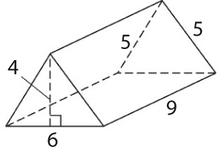

To find the surface area of the regular triangular prism above,   
first find the area of each face or base.

2 congruent triangular bases 3 rectangular faces

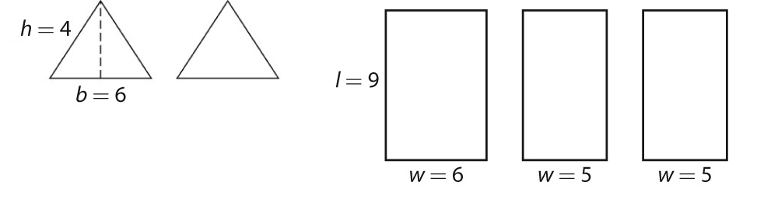

*A*  bh ÷ 2 *A*  ** *A*  **

 6 x 4 ÷ 2  9 x 6 9 x 5

 12 square units  54  45

Then, find the sum of all of the faces of the prism.

*SA*  12  12  54  45  45

 168 square units

The same procedure can be used to find the surface area of a **pyramid**. The areas of the faces are added to the area of the base to give the total surface area.